Overview:

We have decided upon 4 pages for our club, Adventure Club:

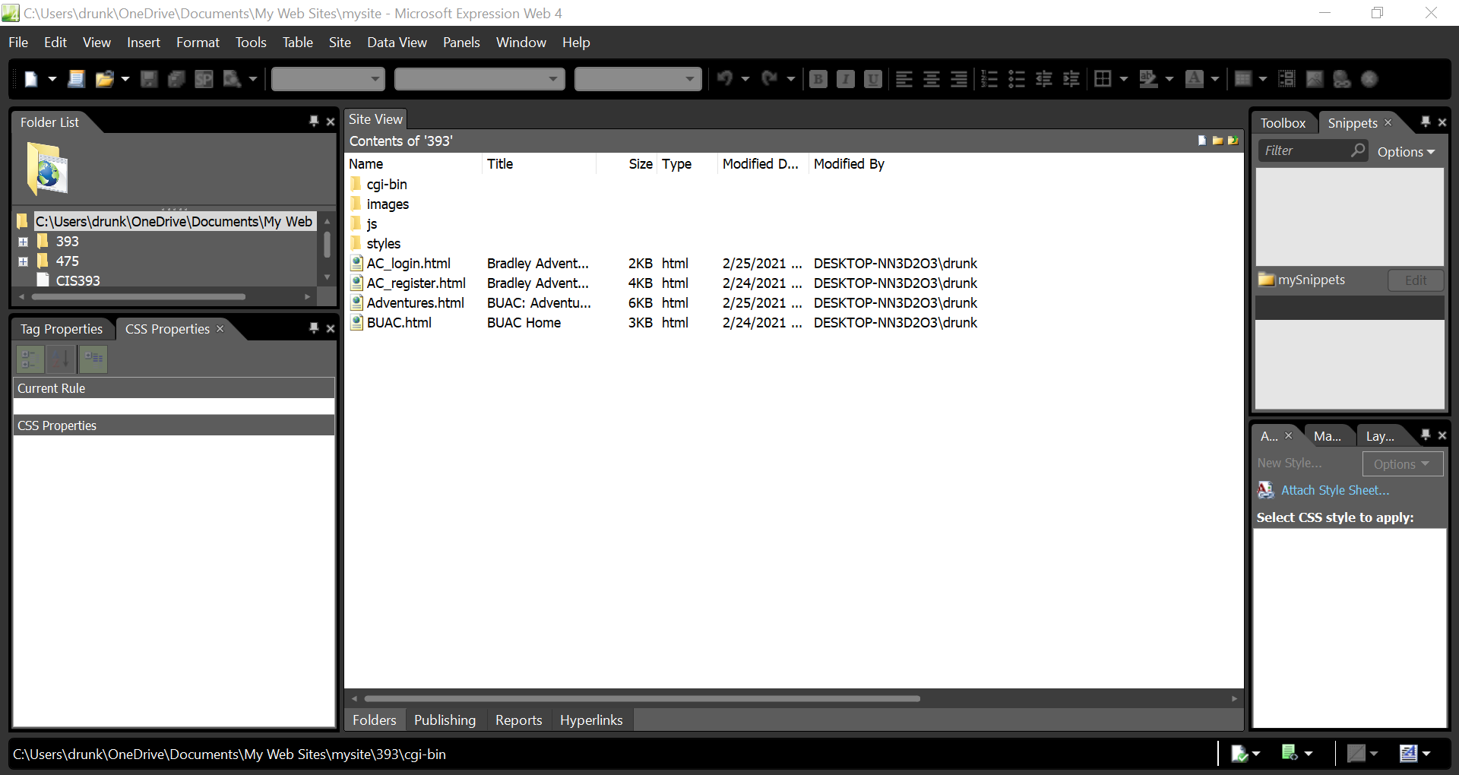

Cgi-bin: we have utilized the same files as the original labs, with modifications regarding what is being taken from the user within the register.

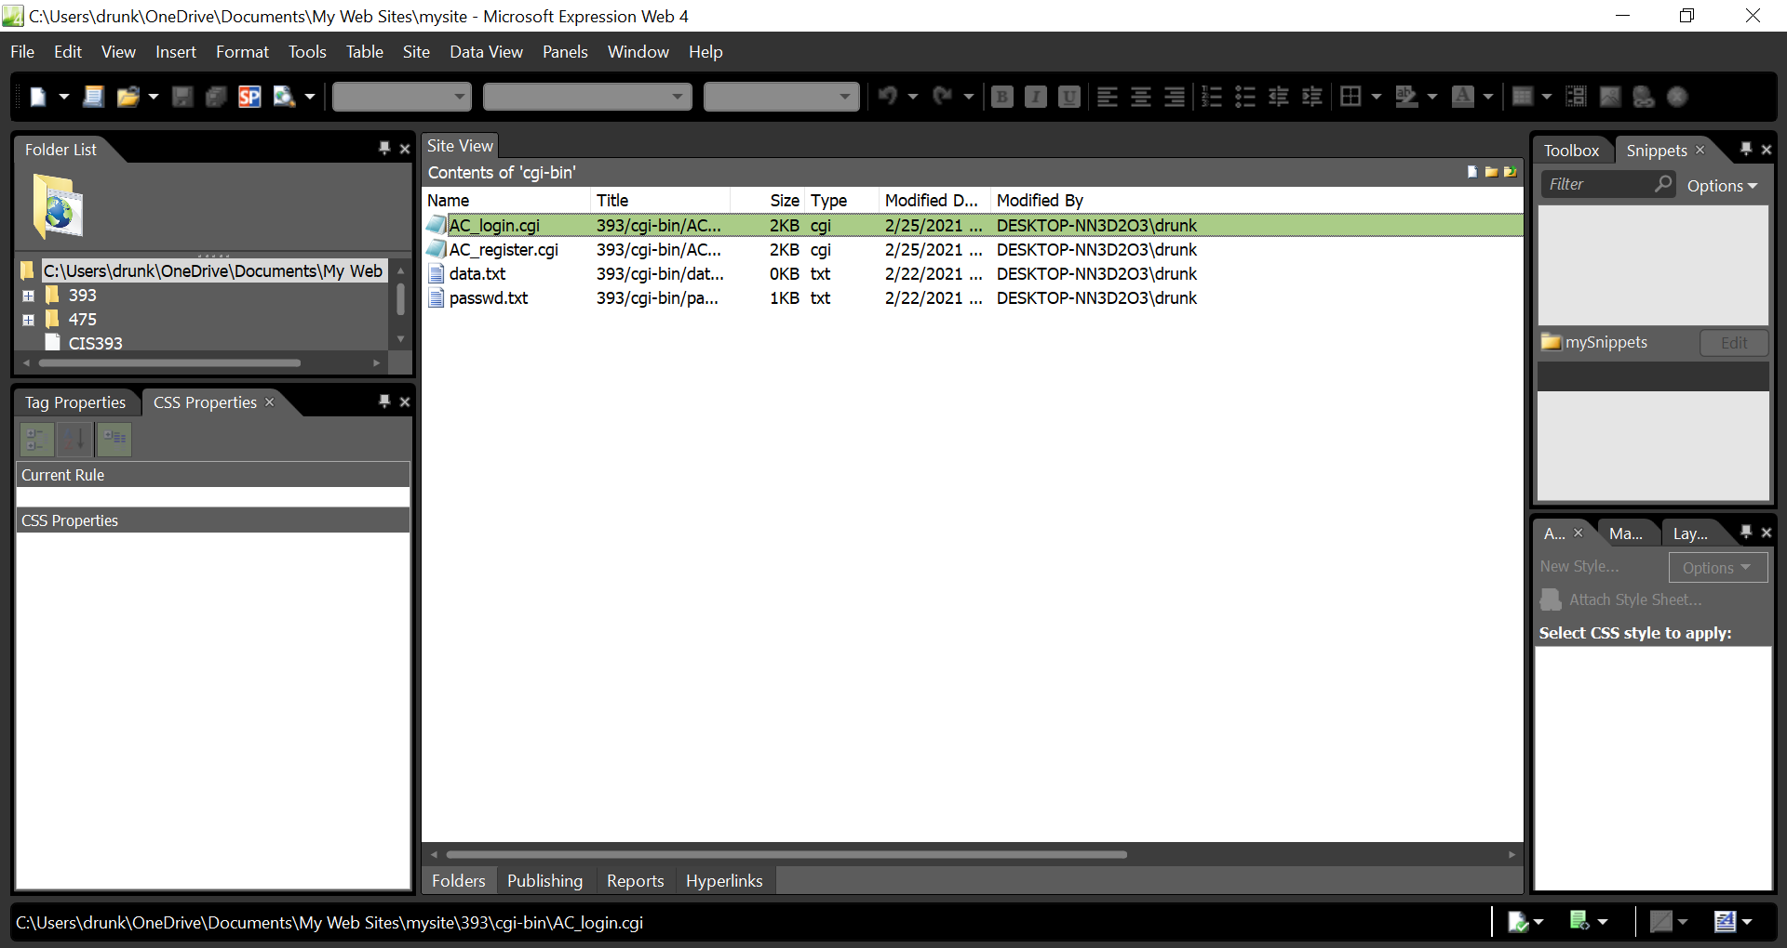

AC_Login.cgi: The login cgi is almost completely the same, with the only main difference being where the page redirects to (on line 32) and some flavor text.

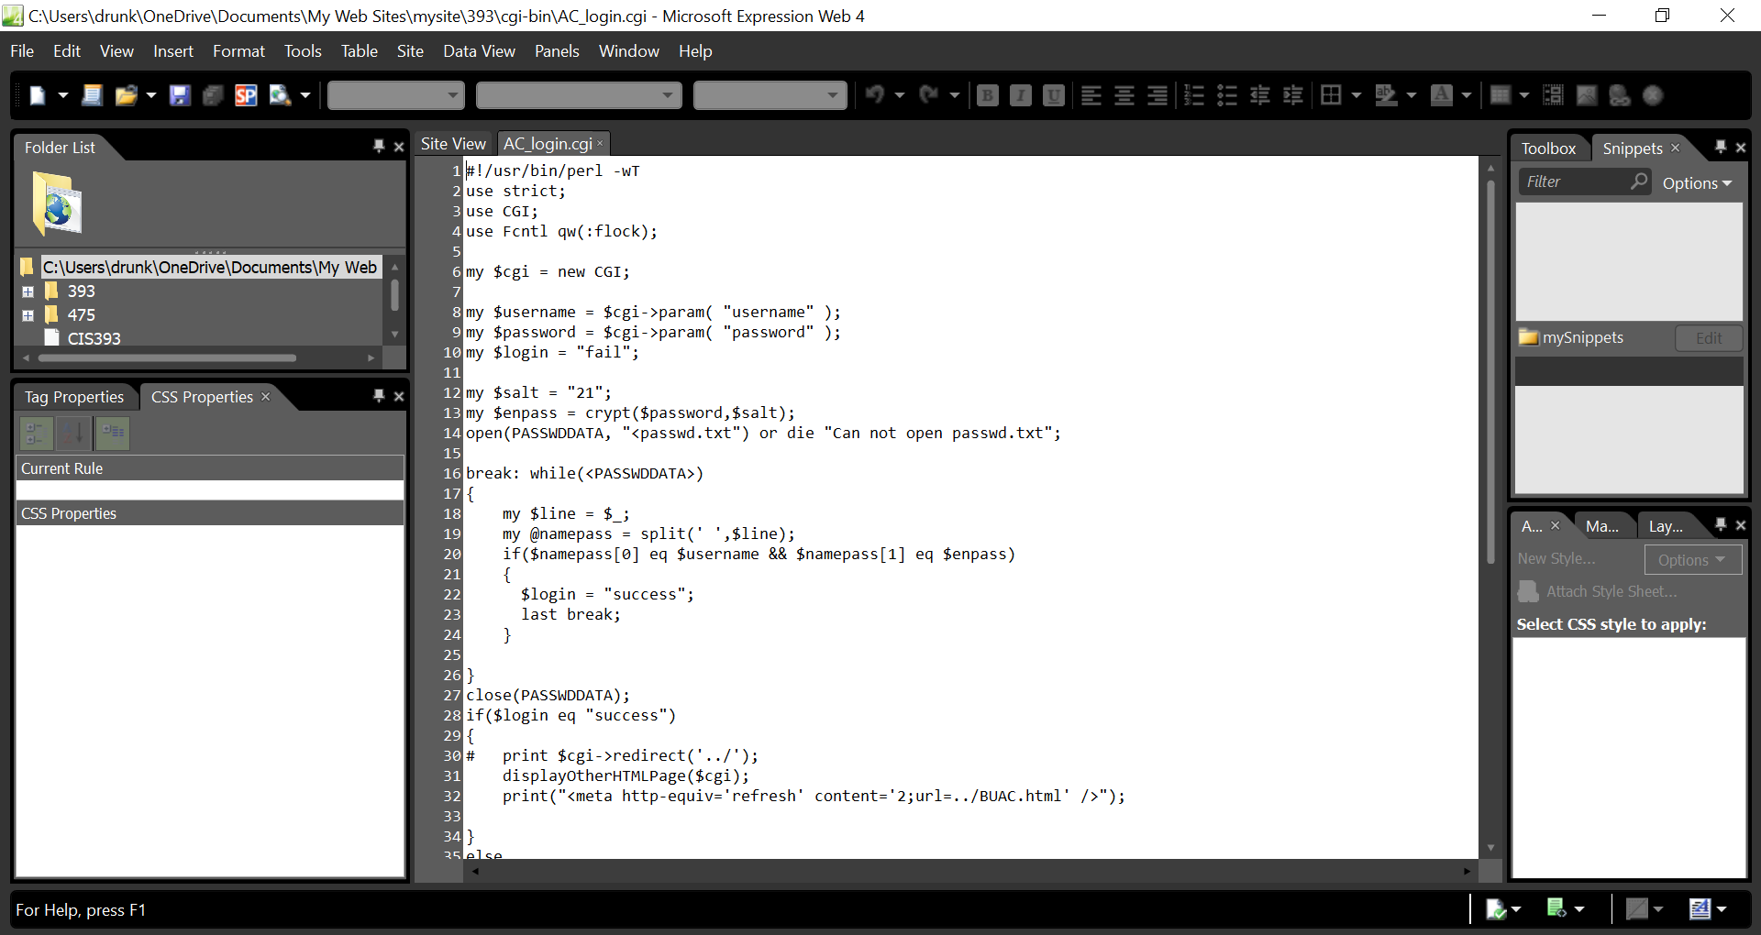

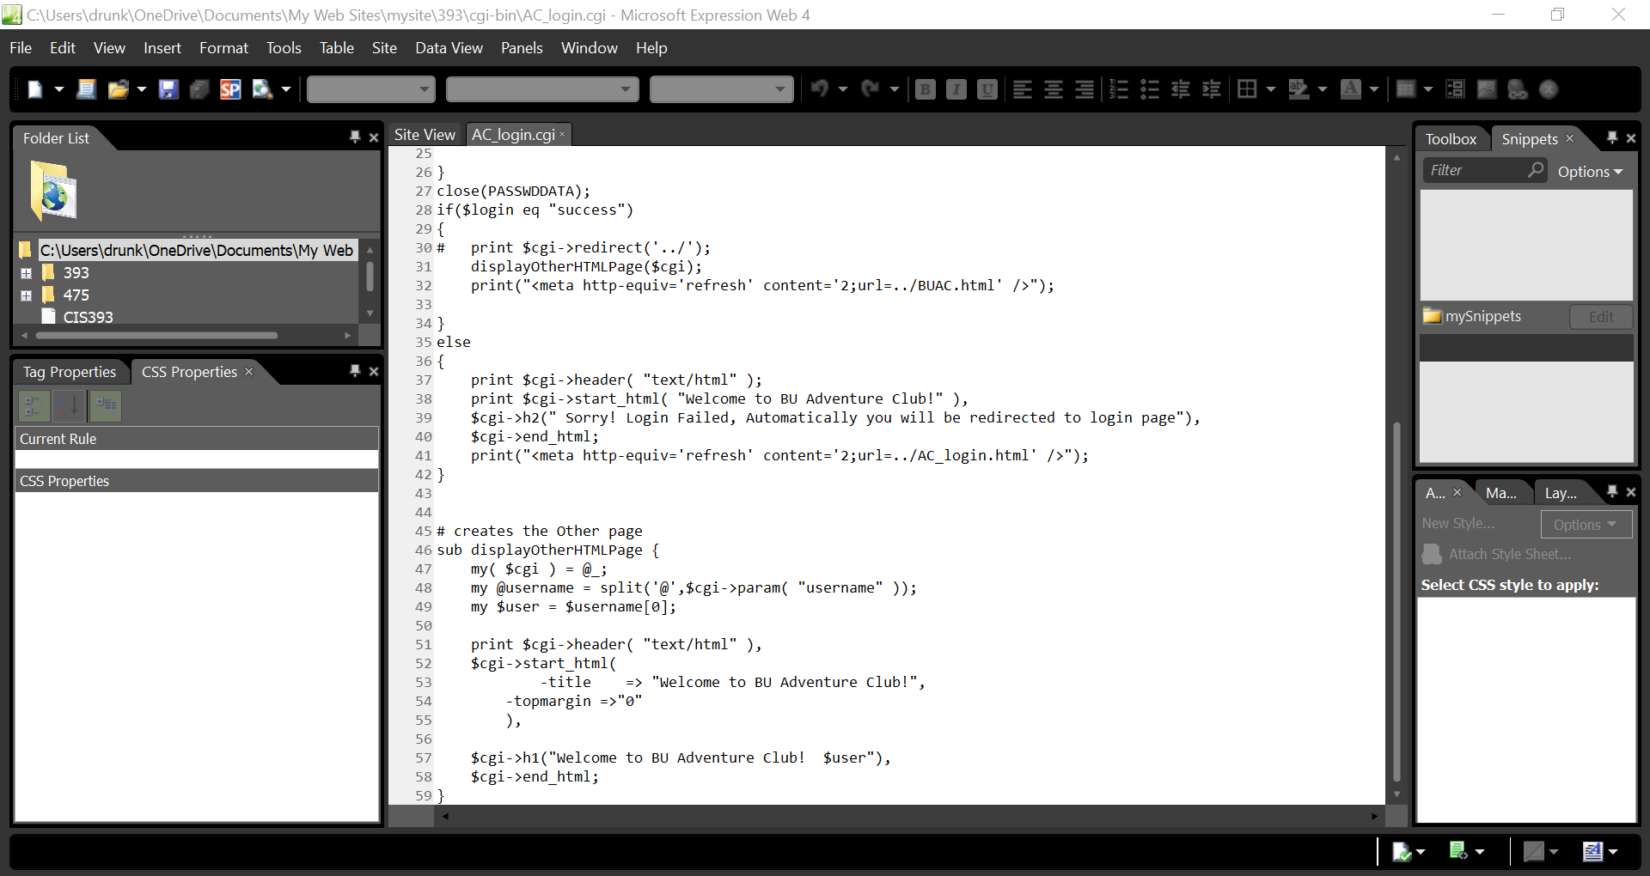

AC_register.cgi: We have done a bit of modification to this document, including fields such as email and studentID. The overall code format from the lab was followed. More variables were created on lines 10 and 11, variable names were fixed to reflect what they were on the register page, and outputs were corrected on lines 20 and 42-50.

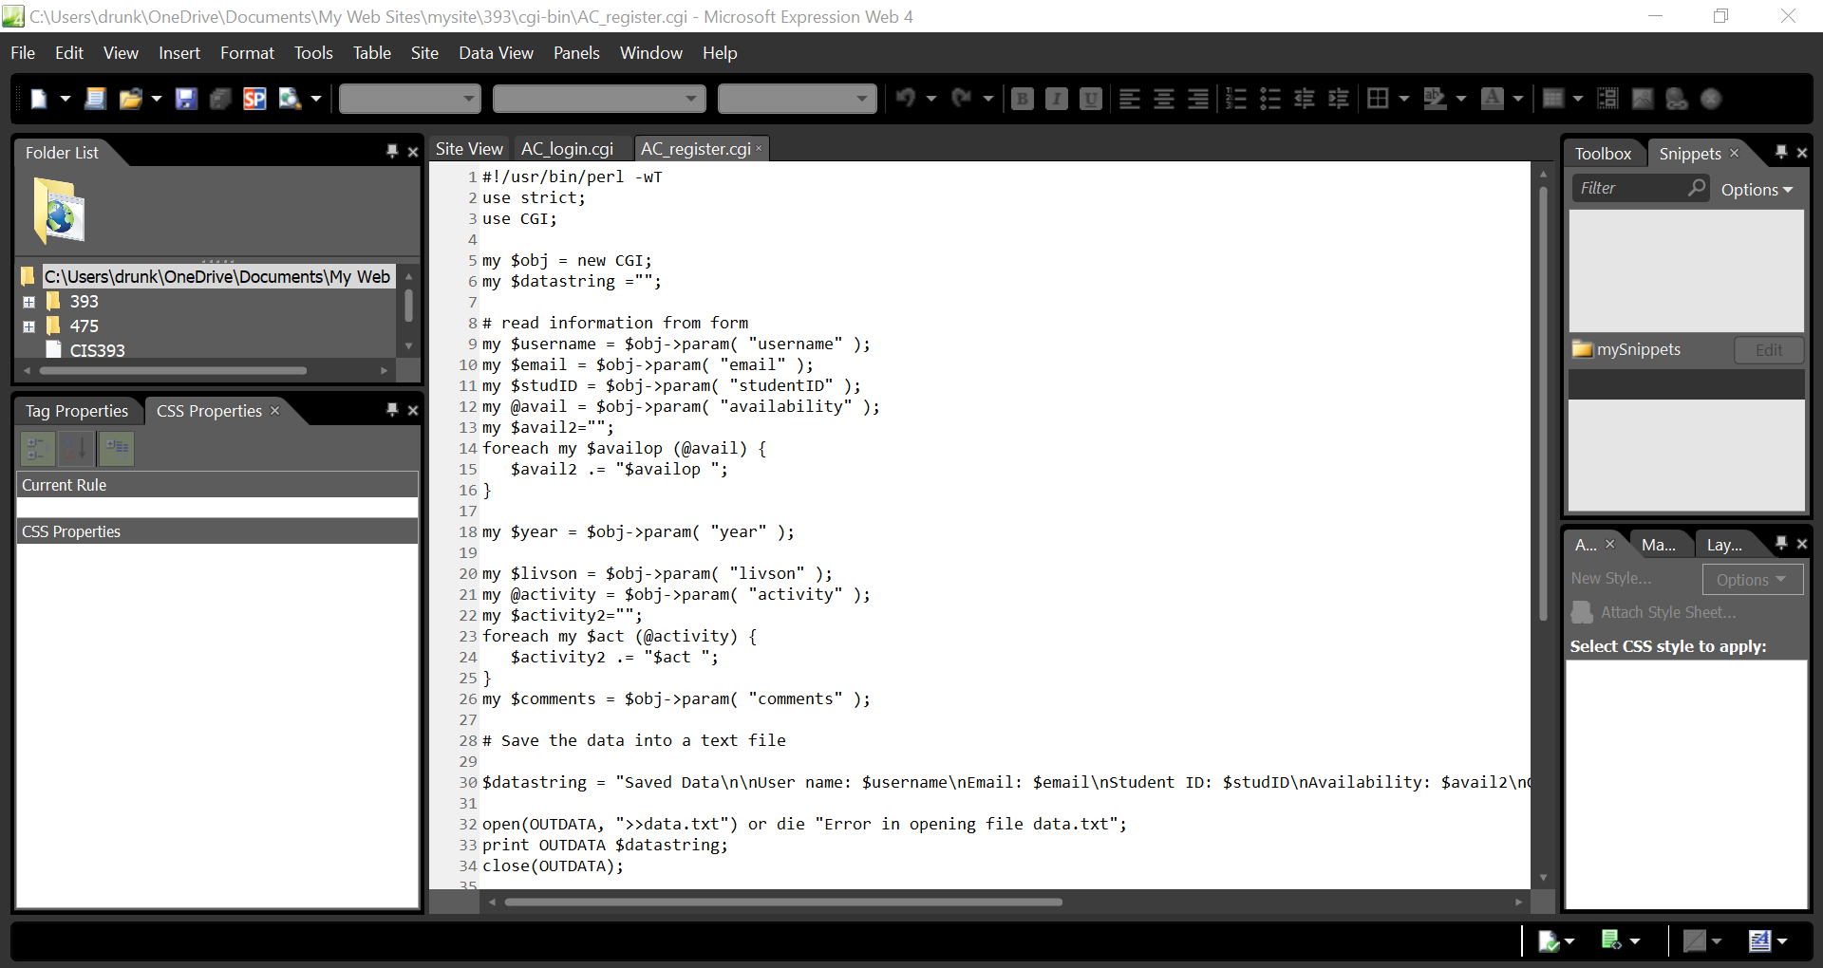

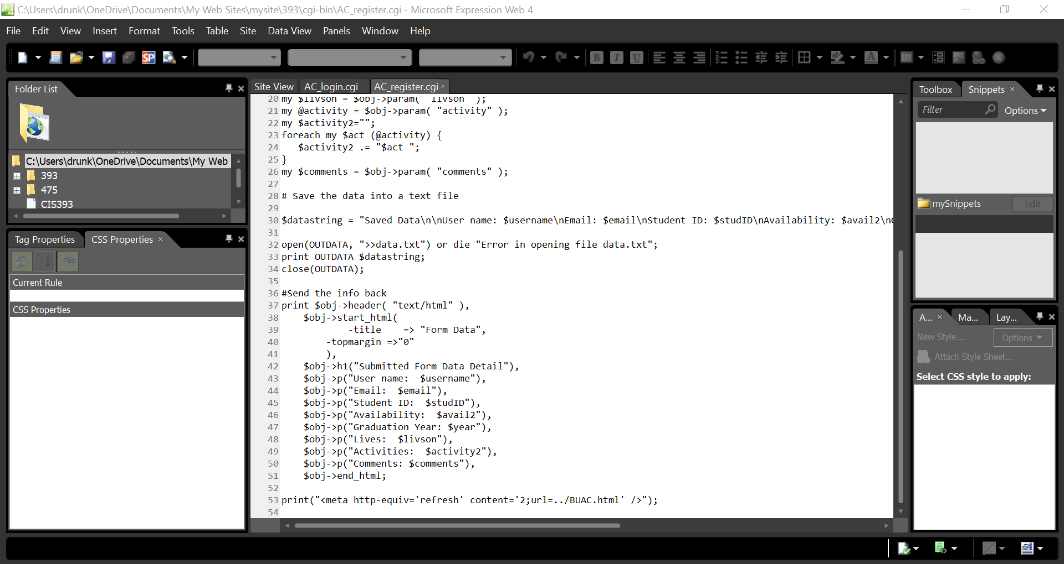

Images: We have utilized quite a few images on our site, and they are all located within this folder.

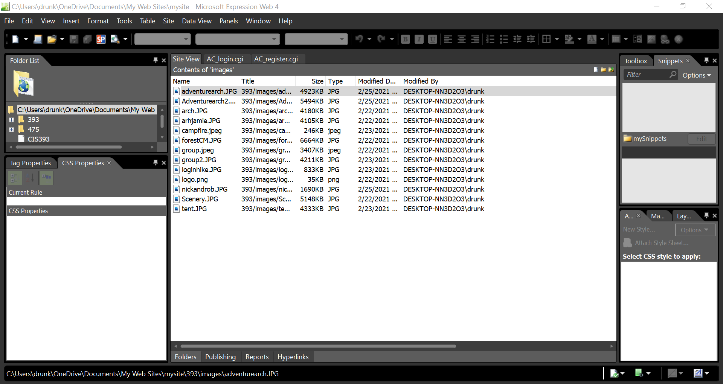

JS: We have added JavaScript code for a slideshow into menu.js. As we are utilizing the menu on all pages anyway, there was no need to make another js file, even though that may have been best practice. This was done on lines 31-57.

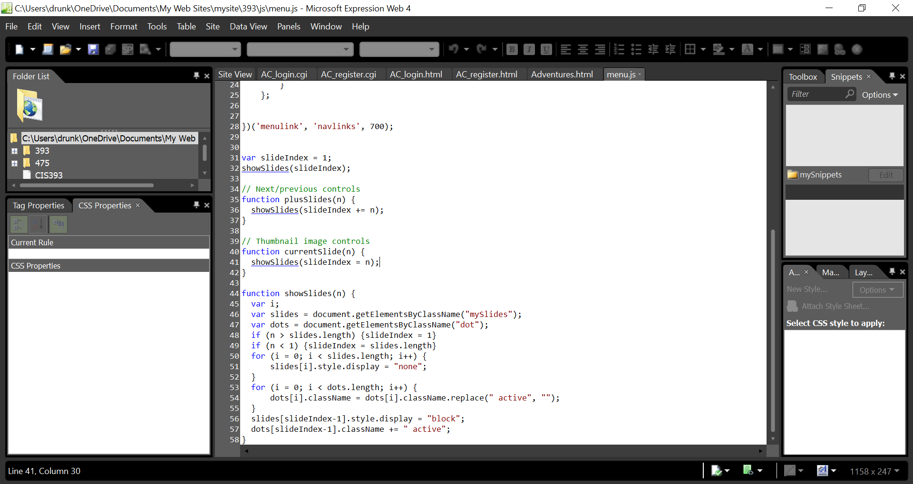

Styles: We added some css code for our slideshow. The following images show the changes.

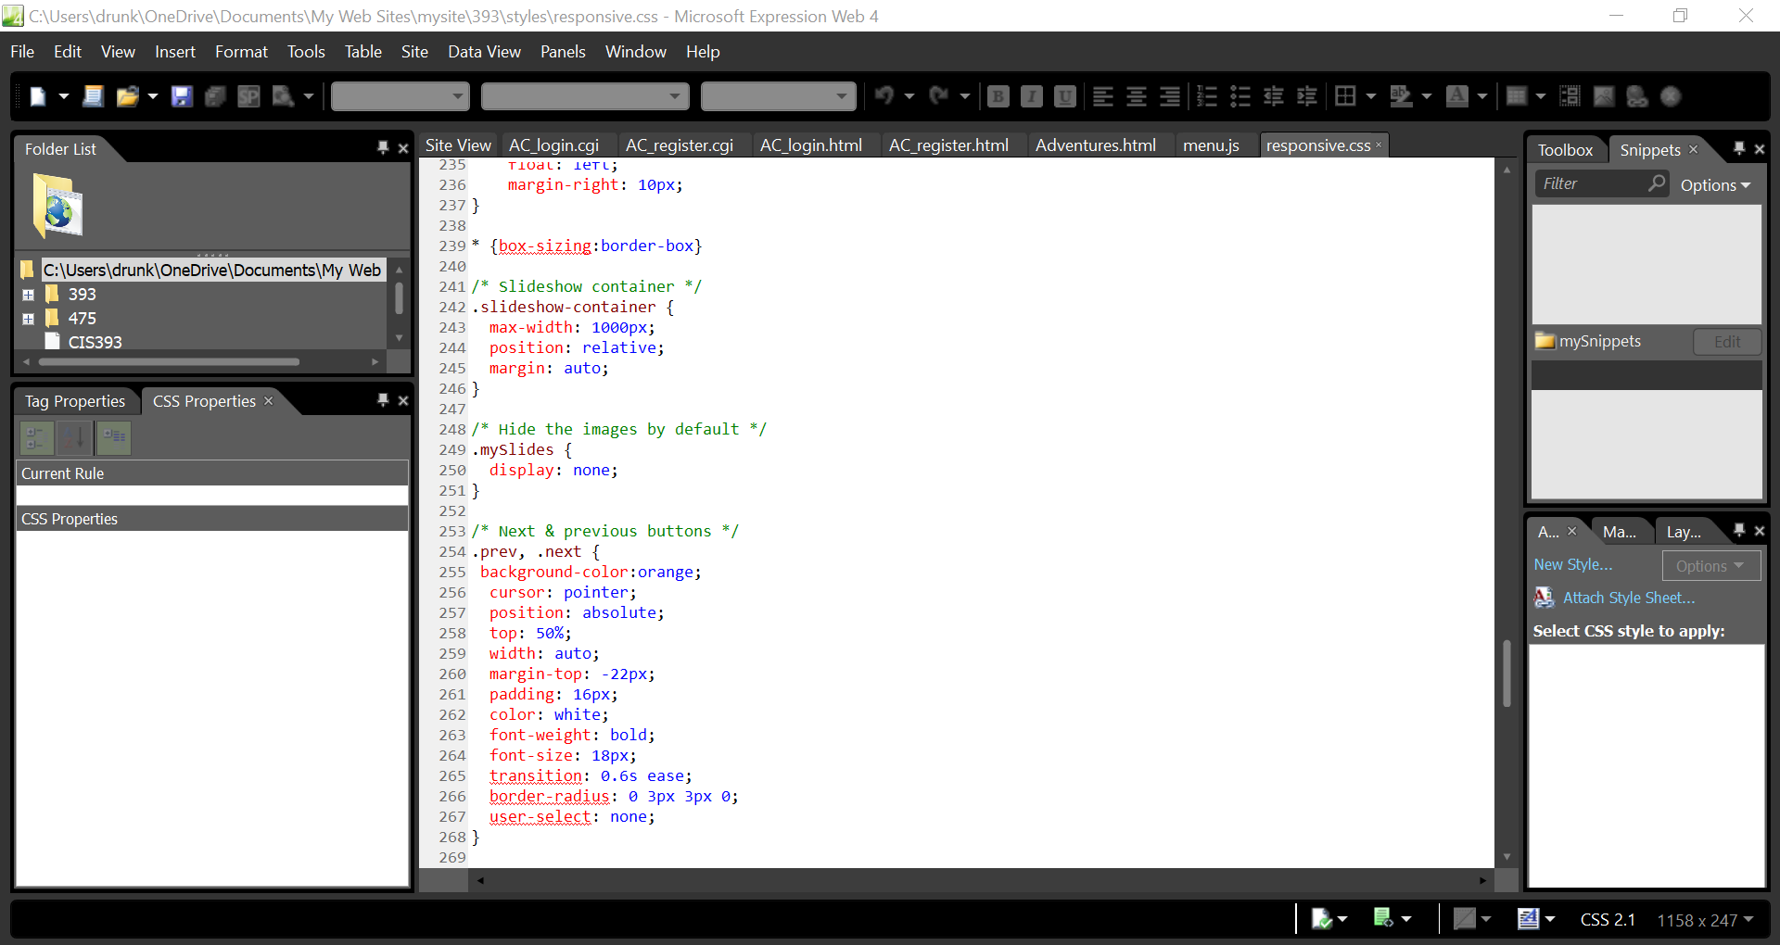

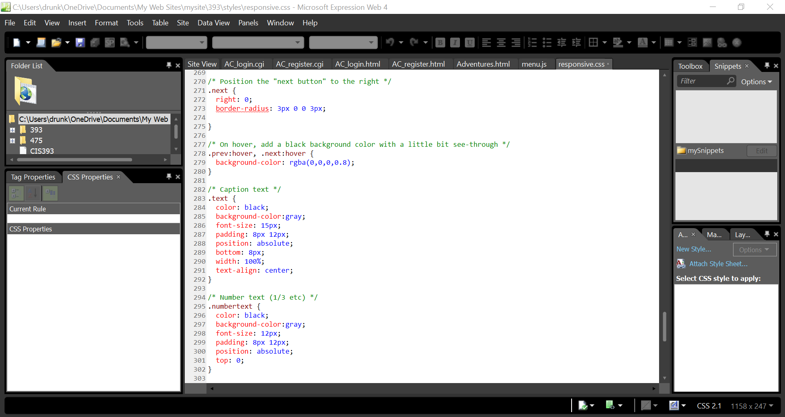

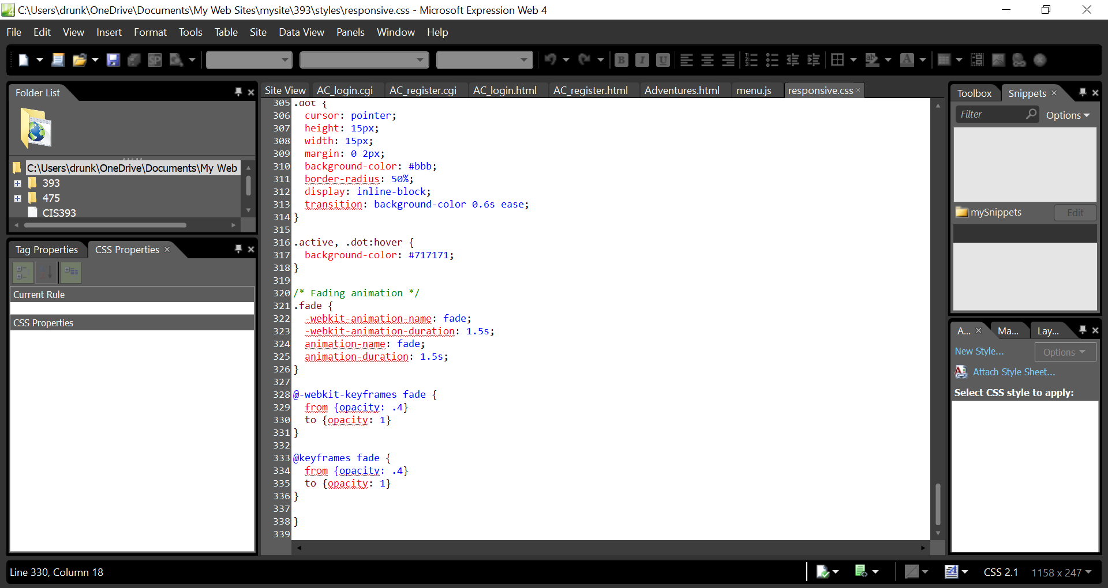

AC_login.html: The login page for Adventure Club. The changes made include adding a menu bar to the page and re-formatting the buttons and text boxes. The menu was copy-pasted almost directly from the home page, and <br> was utilized to split up the fields a little more.

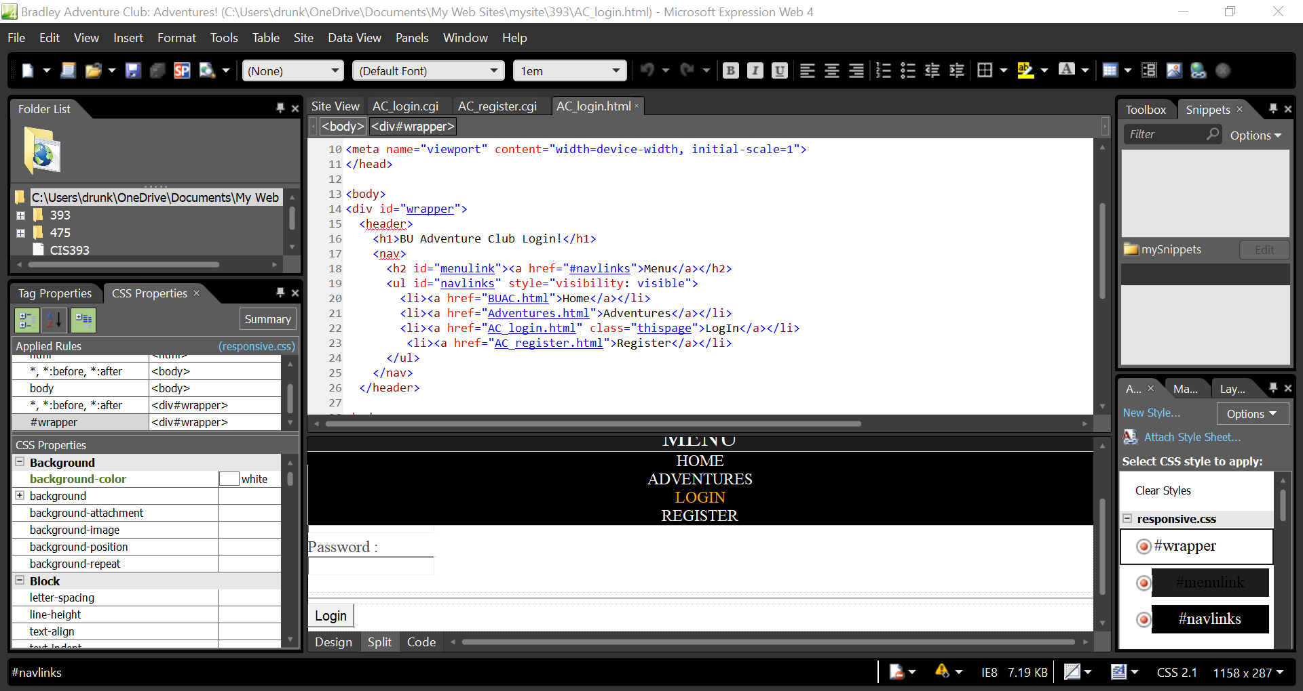

AC_register.html: The register page for Adventure Club. We had decided to keep the overall layout of the questions, just modifying them to suit our needs. We also added an image and made sure the menu bar was present.

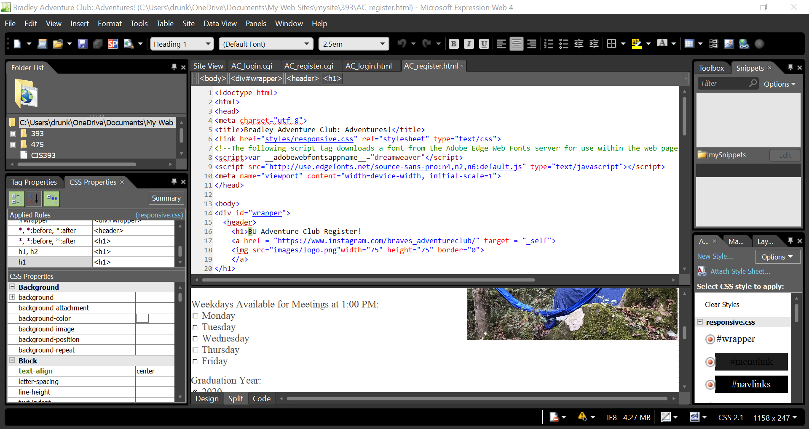

Adventures.html: This is where we are showcasing some of the adventures that Adventure Club has been on. The major changes are within the flavor text and links, as well as the slide show that we have created for this page.

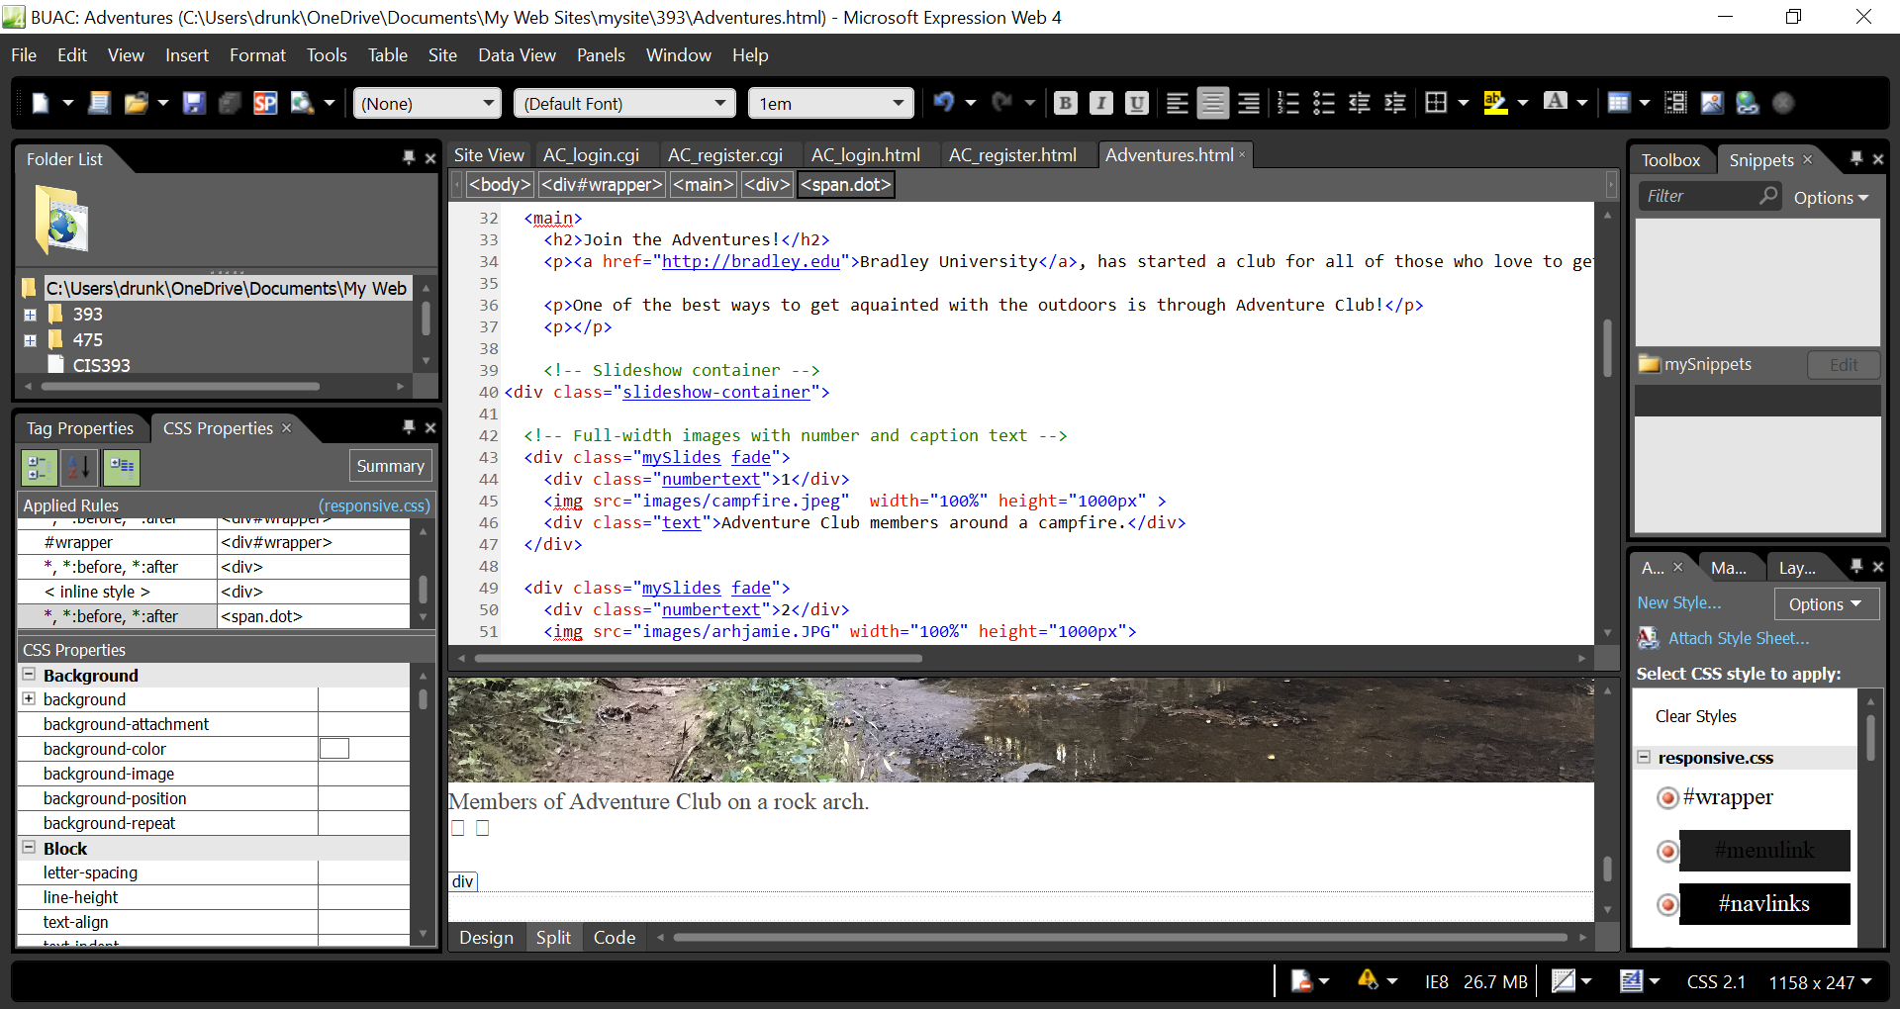

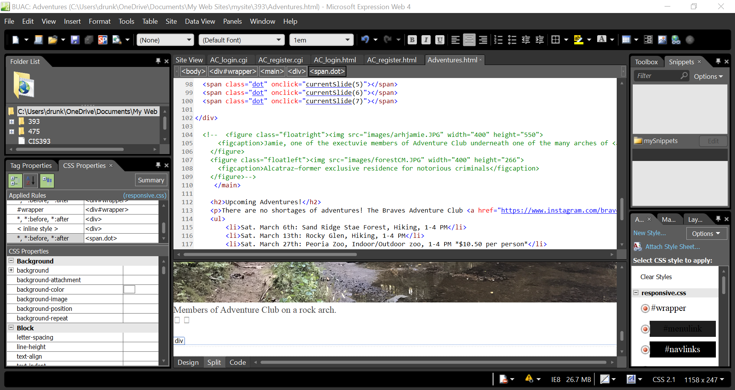

BUAC.html: This was the home page for our club. We have kept the “hero” image, as it was nicely done and have added our own flavor text and images.

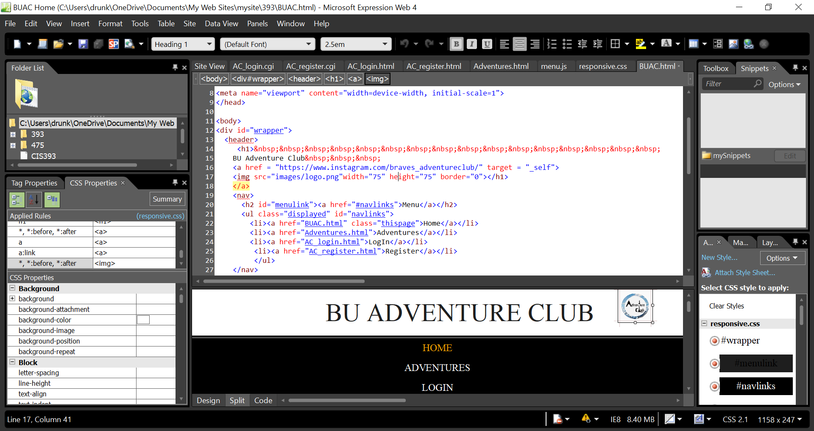

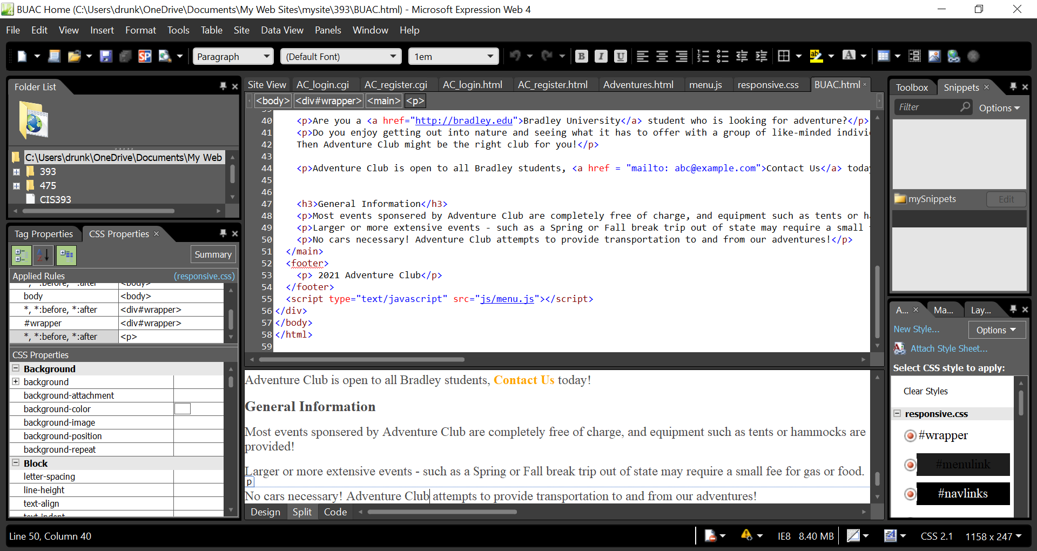

Final Pages:

